**TRADITIONAL YELLOW MAIZE**

**What is traditional Yellow Maize?**

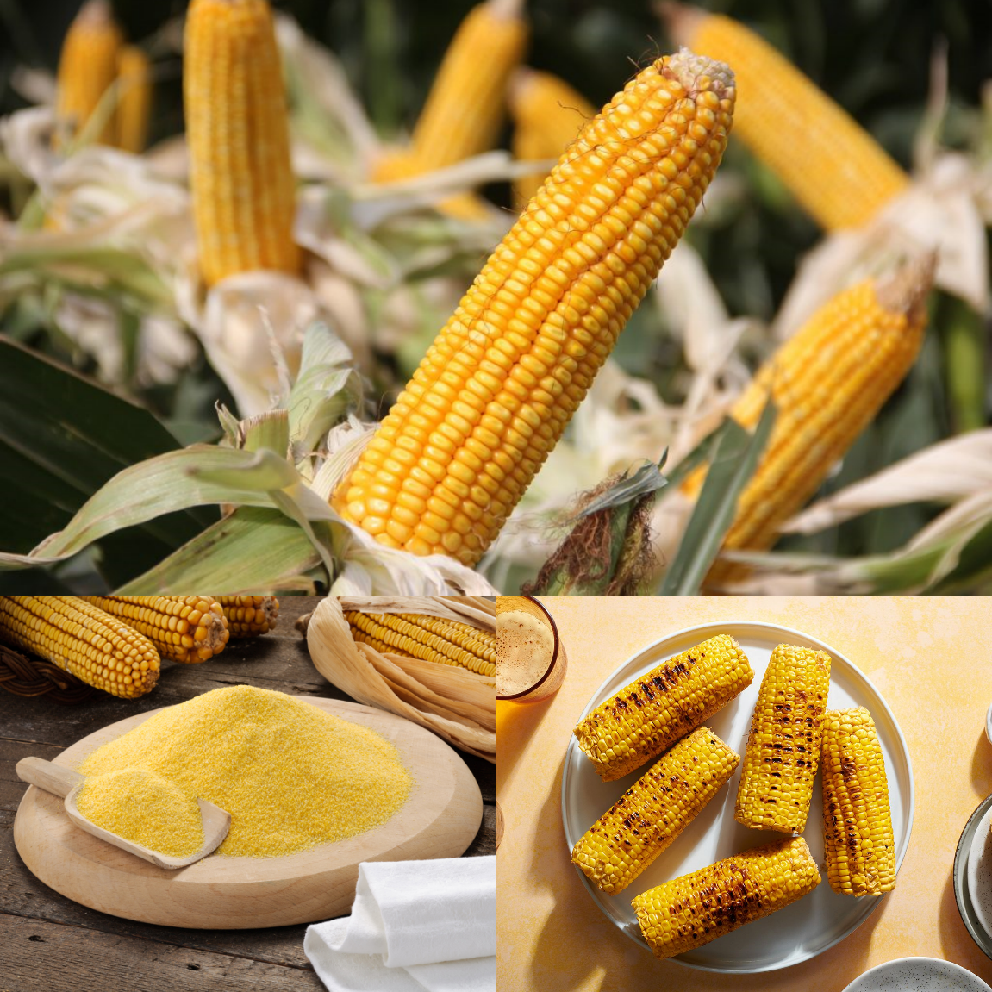

Yellow maize, often known as corn, is a grain that was initially cultivated by Indians in Mexico some 10,000 years ago. Although it is usually consumed as a vegetable, it is a grain or cereal crop, despite its incorrect classification as a vegetable. Depending on the variety, maize comes in a range of hues, including yellow, white, blue, red, black, green, purple, tri-color, and multi-color.

Yellow maize is grown on stalks, which are popularly called corn stalks, and each stalk produces numerous ears of corn with hundreds of kernels. The dried kernels are used for animal feed or crushed into flour for baking, while the cooked kernels are usually consumed cooked.

Because each maize grain is a unique blend of genes acquired from its parents, each maize grain comes from a different individual (the seed of a new plant). The color of the nutritive layer that surrounds the embryo in the seed, termed the endosperm, distinguishes yellow and white maize grains.

**Yellow Maize and its Benefits to People and Livestock**

Commercially, yellow maize is grown in enormous quantities and harvested fresh for human consumption. Fresh corn is available whole, with the silk and husks still attached, as well as cut from the cob with the kernels frozen or canned for use in recipes or as a vegetable side dish. After that, the fresh, tinned, or frozen kernels are boiled or prepared in some other way before being eaten.

**The Nutritional Value of Yellow Maize**

Yellow maize is healthy and high in nutritional content, despite its flavor and vibrant color. Because of its greater quantities of Lutein, Carotenoids, and vitamin A, yellow corn has been shown to have a higher nutritional value than white corn.

Maize is a nutritious delight for all of us, which is why it is a staple diet in many regions of the world. It has a high fiber and protein content while being low in fat and sodium. Maize has a lot of minerals that are important to us, and it has a lot of them. Phosphorus, Magnesium, Manganese, Zinc, Copper, Iron, and minor levels of Calcium and Potassium are among these minerals.

**Yellow maize is also good for livestock**

Yellow maize stalks can be used as fodder for livestock such as cows, sheep, goats, horses, and other livestock. They can also be fed to chickens and roosters as a source of protein. This stock should be collected when it is green in order to use it as both a source of food for cattle and a source of grains. The vegetable part is then used to extract the grains, with the remaining sections being used as livestock feed. Because it is so nutrient-dense, this is an extremely beneficial feed for livestock.

**Ways you can use yellow maize**

Cornmeal or corn flour are terms used to describe finely ground yellow maize. Pancakes, waffles, cornbread, muffins, and other baked items can all be made using this. In dry cereal products, commercial cereal manufacturers frequently employ ground maize. Yellow maize is a versatile crop that may be used to make corn syrup, grain alcohol like bourbon, corn oil, and biofuels, among other things. During the autumn months, many corn farmers build up labyrinths and mazes in their fields, offering tours and other harvest activities.

**What's the Difference Between White and Yellow maize?**

To be honest, not much, at least in terms of taste. Although some people believe yellow maize is sweeter than white maize, this is not the case. The main difference is that beta carotene, the naturally occurring pigment that gives those kernels their yellow color, gives them a nutritional advantage over white maize since beta carotene is converted to vitamin A during digestion.

Other differences according to Master Class staff (https://www.masterclass.com/articles/white-corn-vs-yellow-corn#white-corn-vs-yellow-corn-whats-the-difference) include:

* **Appearance:** The color of the kernels is the key distinction between these two types of corn. White corn has white or cream kernels, while yellow corn has pale yellow to dark yellow kernels.
* **Nutritious value:** Because the pigment that colors corn yellow, beta carotene, is converted to vitamin A when ingested, yellow maize has somewhat more nutritional value than white corn. Lutein is also abundant in yellow corn.
* **Sweetness:** The flavor profile of corn is determined by the variety, not the color of the kernels. Sweet corn, which can remain a long time off the corn plant without losing its water content and turning starchy, is the most common type of corn sold in the United States. Standard, sugar-enhanced, and super-sweet sweet corn are the three main varieties, all of which can have white or yellow kernels.

**How to prepare yellow maize ugali**

It's a dish that's prepared all over Africa. If you haven't tasted this maize, now is your time. It's been prepared for hundreds of years all over the world, and if you haven't, now is your chance.

**Preparation time of 2 minutes**

**13 minutes of cooking time**

**15-minute total duration**

**Ingredients**

* Ingredients: 2 cups yellow maize flour
* 4 cups water

**Procedure**

* In a medium saucepan over medium heat, bring water to a boil.
* The temperature should not be too hot.
* Allow the water to begin to bubble.
* Pour in the flour and let it soak up enough water to cover it.
* Start stirring.
* The ugali will start to take up rigid shape.
* Now compact it into a dome shape.
* Transfer to a serving plate.
* Serve with a side of kales.

So that's going to be the end of this delicious yellow maize ugali dish. Thank you so much for taking the time to read this. I'm convinced you'll be able to make it at home. Remember to bookmark this page and share it with your family, friends, and coworkers. Thank you for taking the time to read this.

Please contact us if you want to order yellow maize flour. To place an order, call or text Stephen's Natural Foods right now.